

A Project Report On

**SPORTS--BLOG**

**By**

**Sivasubramanian.T**

**Batch :** 2022 – 7888

**Center : Bangalore - Jayanagar**

Under the Guidance of,

**Chittaranjan Ghosh.**

**Technical -Trainer**

**EduBridge**

(Digital Academy – Certification program in Java Full Stack)

## INTRODUCTION:

The projects while learning a programming language is really fun and exciting. We are going to make a simple SPORTS BLOG project using Spring Boot REST Api. It's possible to make a complete functional blog project and GUI in java. In our simple SPORTS BLOG project, the user can see post , comment .But to add post, add comment, update post, update comment they have to first signup and signin to the user account.

**MODULES:**

* **Admin Module 🡪** In Admin module , the admin can check the users account, post, comments and the admin can manage users, manage posts, manage comments for the existing account of the user.
* **User Module 🡪** In User module, the user can view the post, comment of the posts. And the user need to add the new post and comment, they must to signup and signin their account to further proceed in the application.

I have developed this Application in **Java, JSP, Servlets, Hibernate and MySQL.** It’s a web-based projects so I have used **HTML, CSS, JavaScript and Bootstrap ,Thymleaf**.

The main objective of the Sports blog is to view the post and comments of the Sports category like Cricket, Football, Hockey, Kabaddi, Volleyball, etc… When the user need to add the new post and add comment for the

existing post , they must have to signup the account .Now the user can do add post , add comment. And they can update post their own post in available category. In Admin module, admin can add more category in the website. Admin can only see the admin page and the user have do any vulgur comments and posts, the admin can remove from the account .

## SOFTWARE REQUIREMENTS:

**Frontend :** Java/J2EE technologies (Servlet, JSP), HTML,

CSS,JavaScript, Bootstrap, Thymleaf, Hibernate.

**Backend :** MySQL Workbench 8.0 C E .

**Middleware/ Server :** Apache Tomcat v8.5. IDE: Spring tool suite for

Java EE Developers

**Browser :** Google Chrome

**Operating system :** Windows 10

**MySQL - Data Dictionary :**

* Create database blogsportsdb

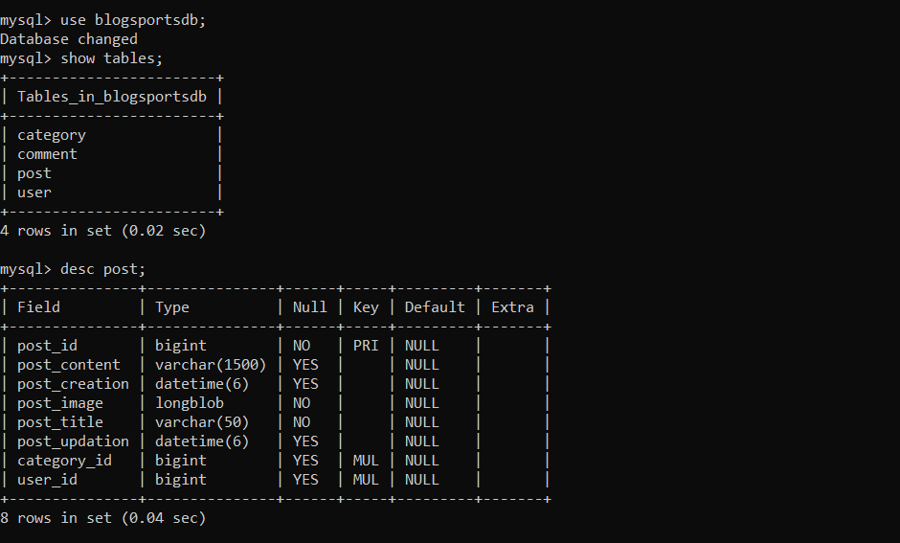

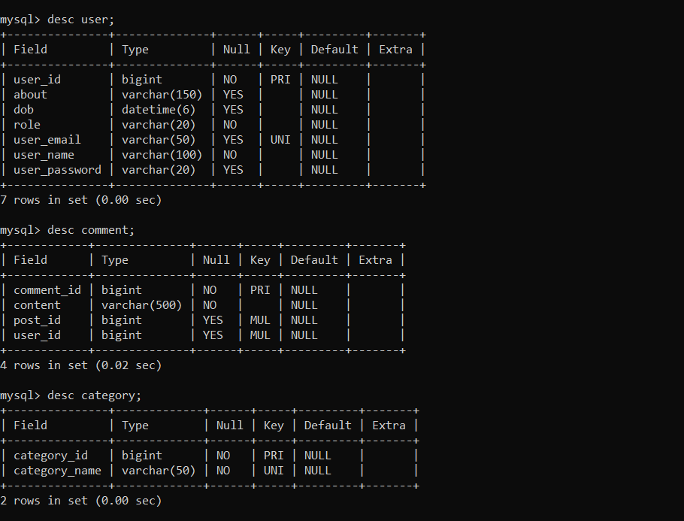

**Screenshots :**

* Home Page :

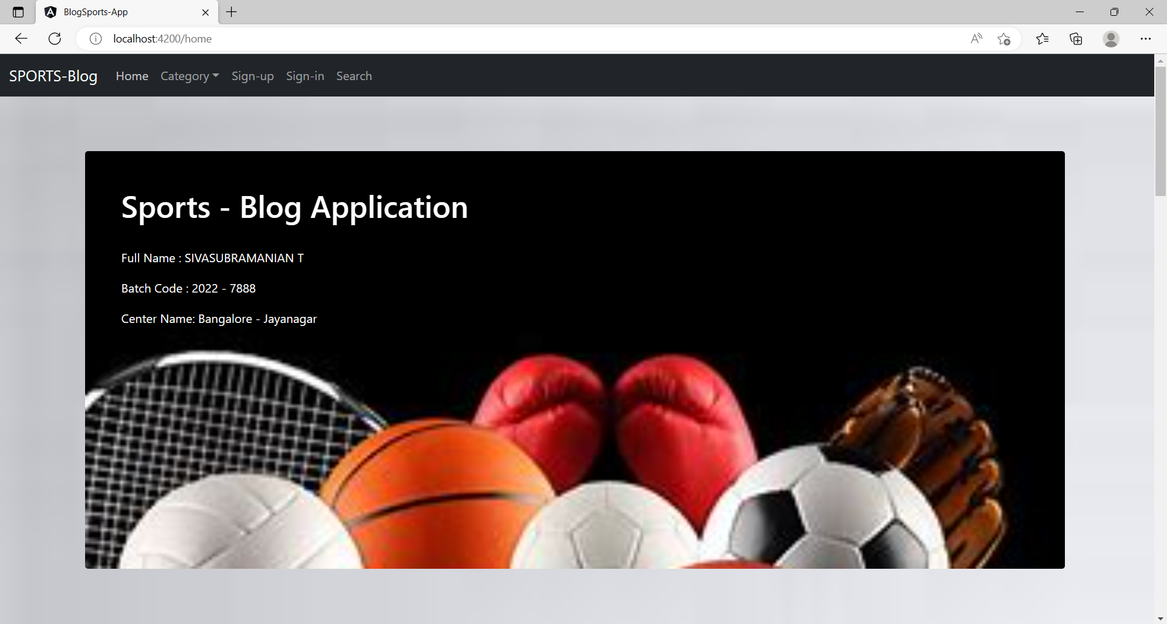

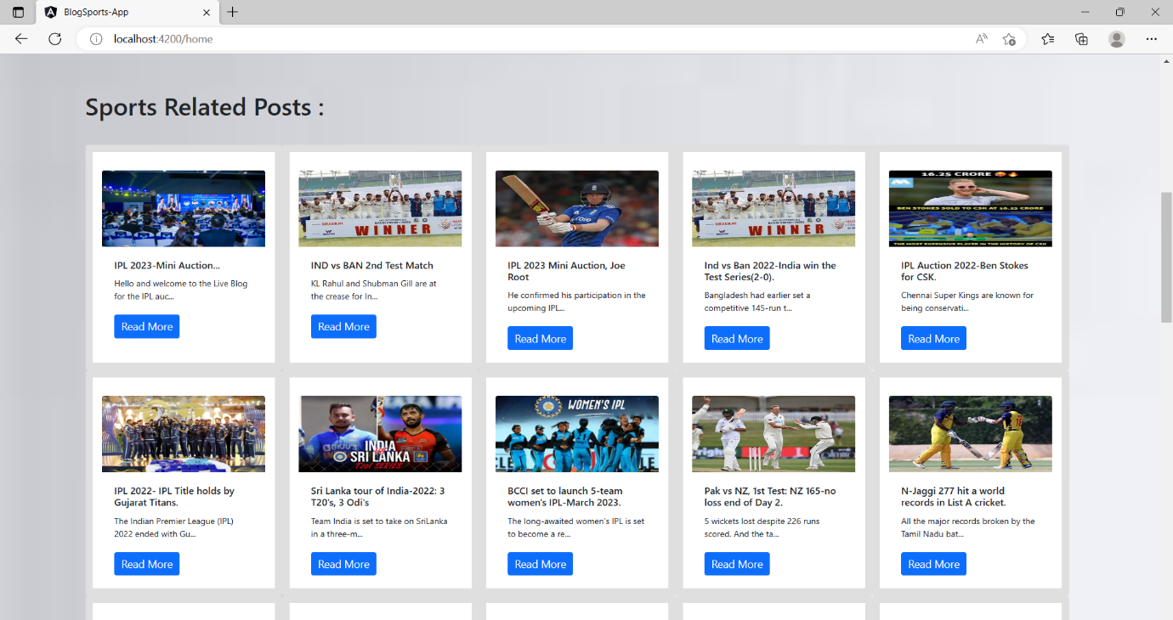

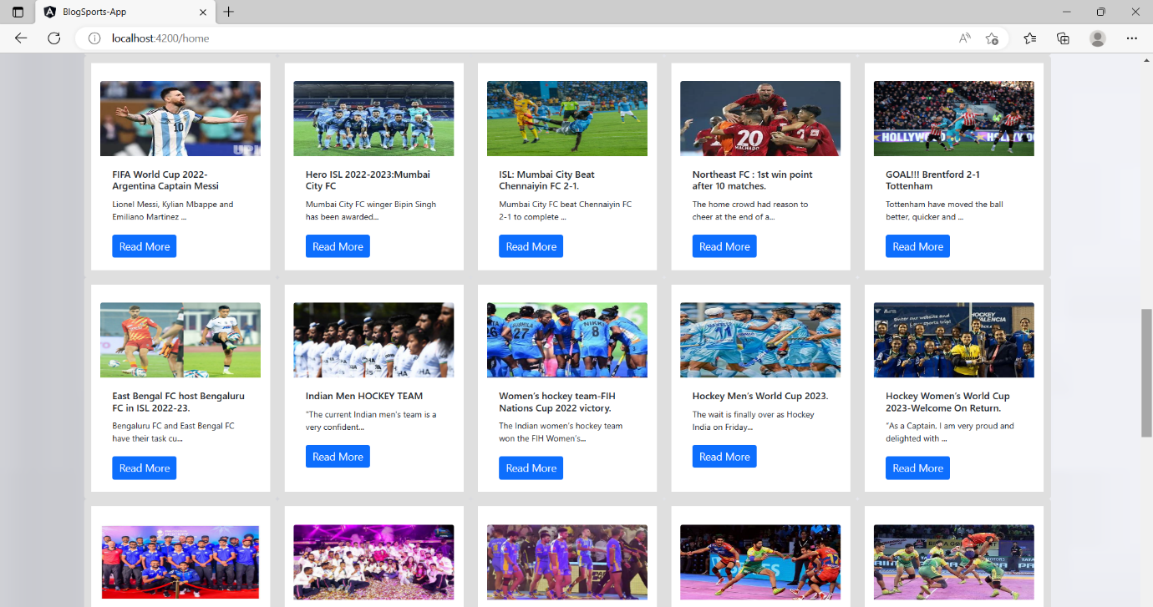

**Users :**

* 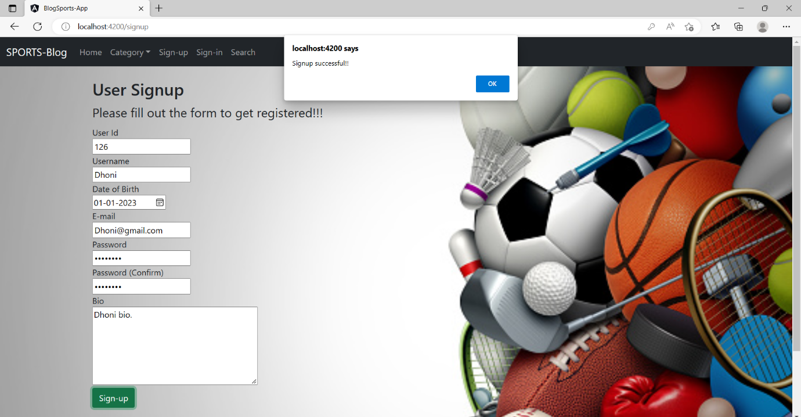SignUp Page :
* SignIn Page :

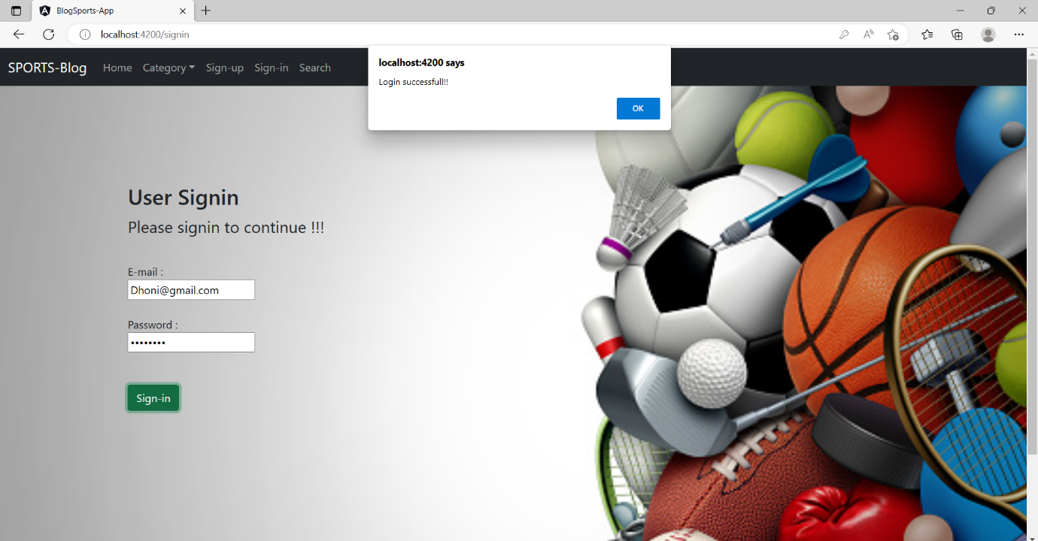

* Dashboard Page :

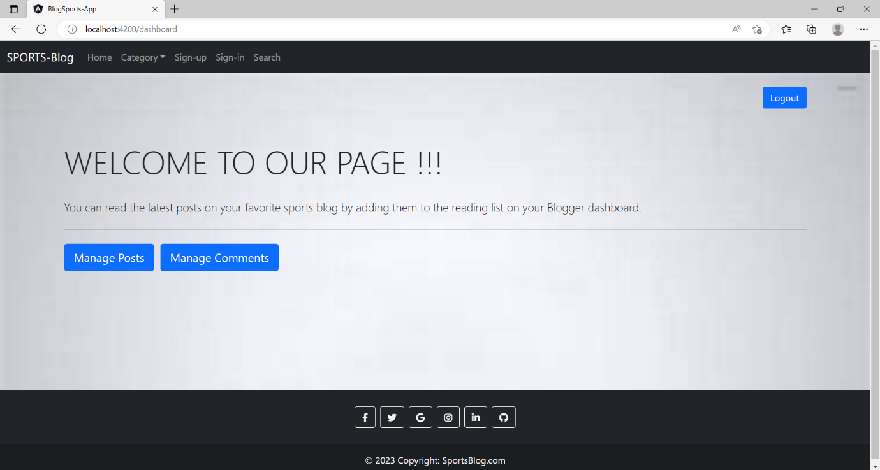

* Add new Post :

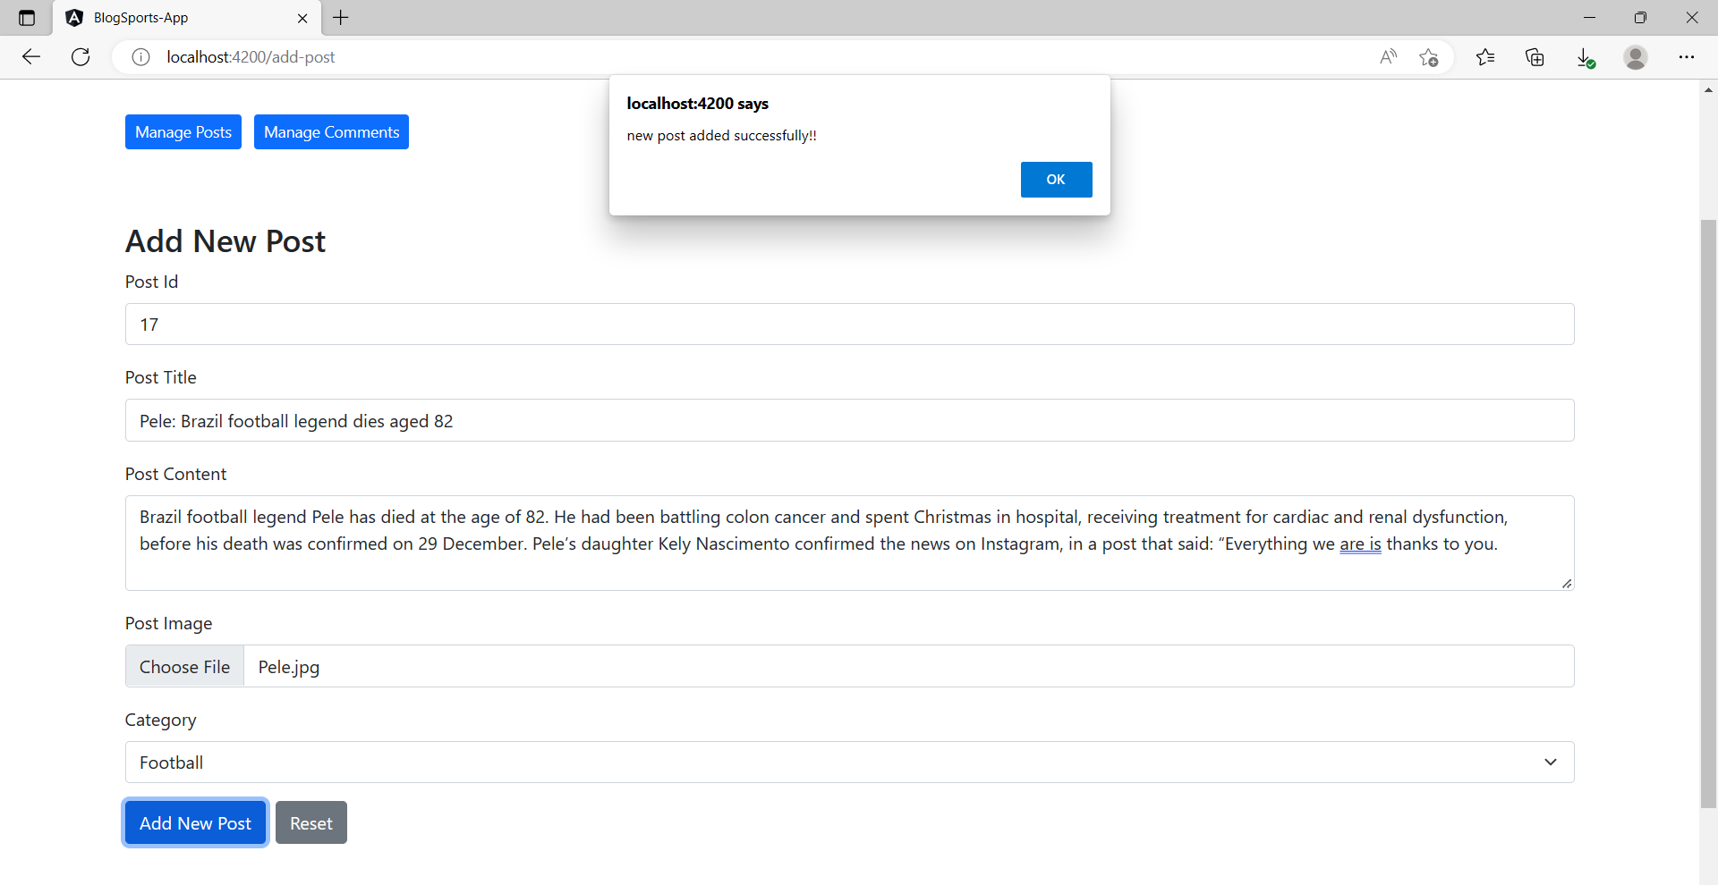

* Add new Comment :

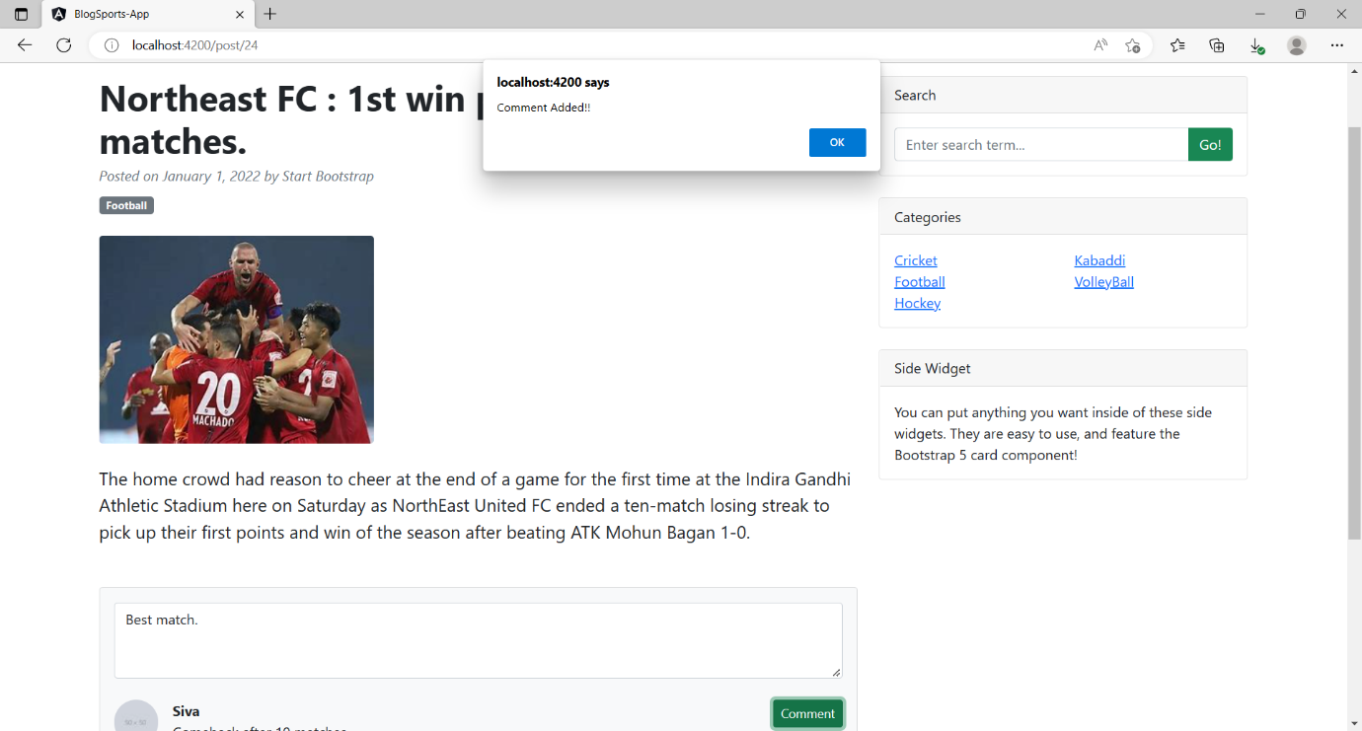

* Search Post by Post name :

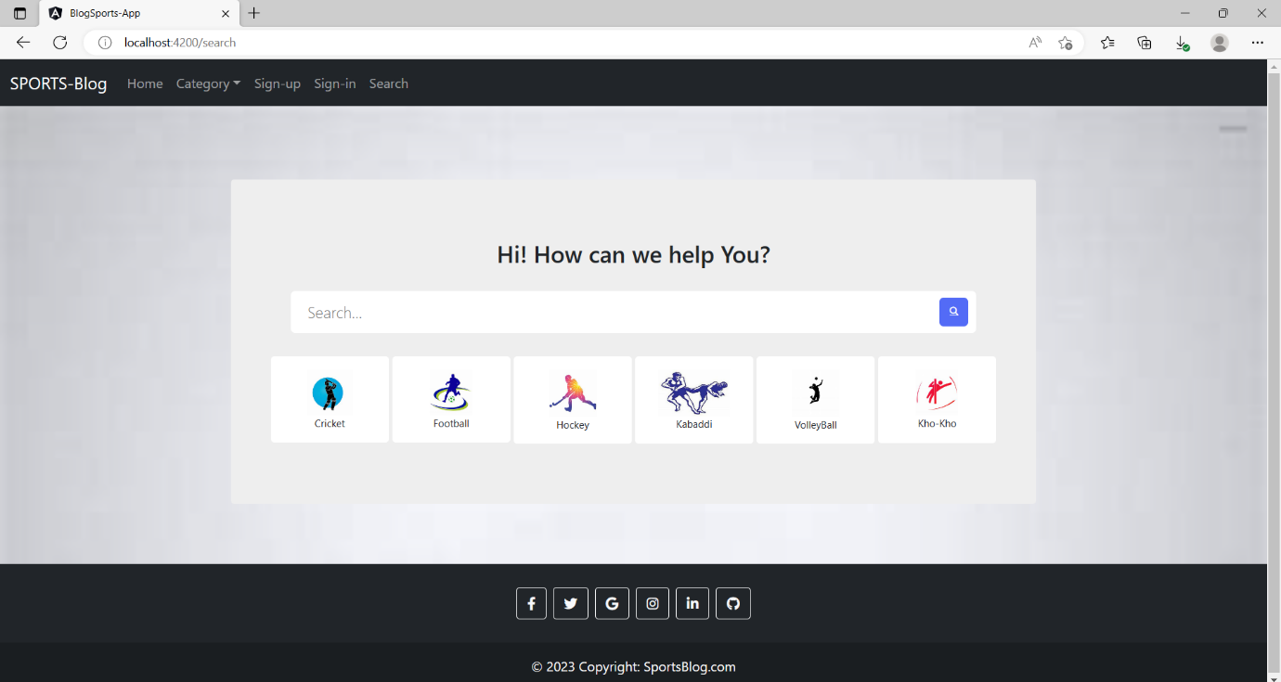

* Searched post by User :

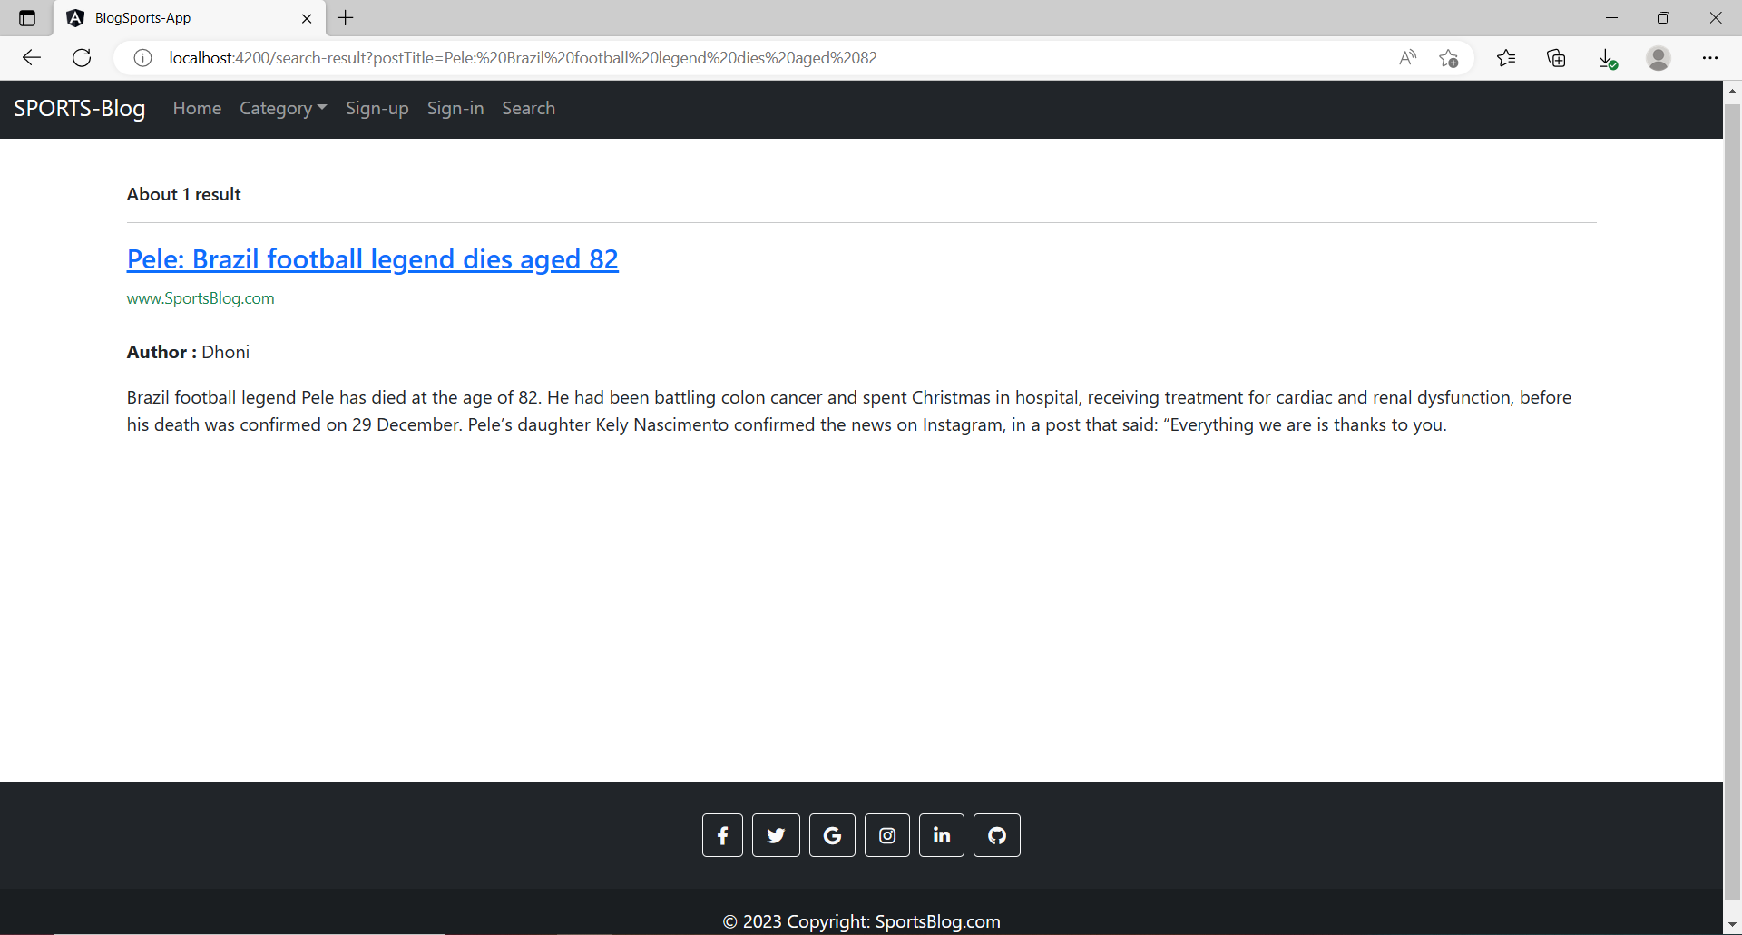

* User Delete their own post :

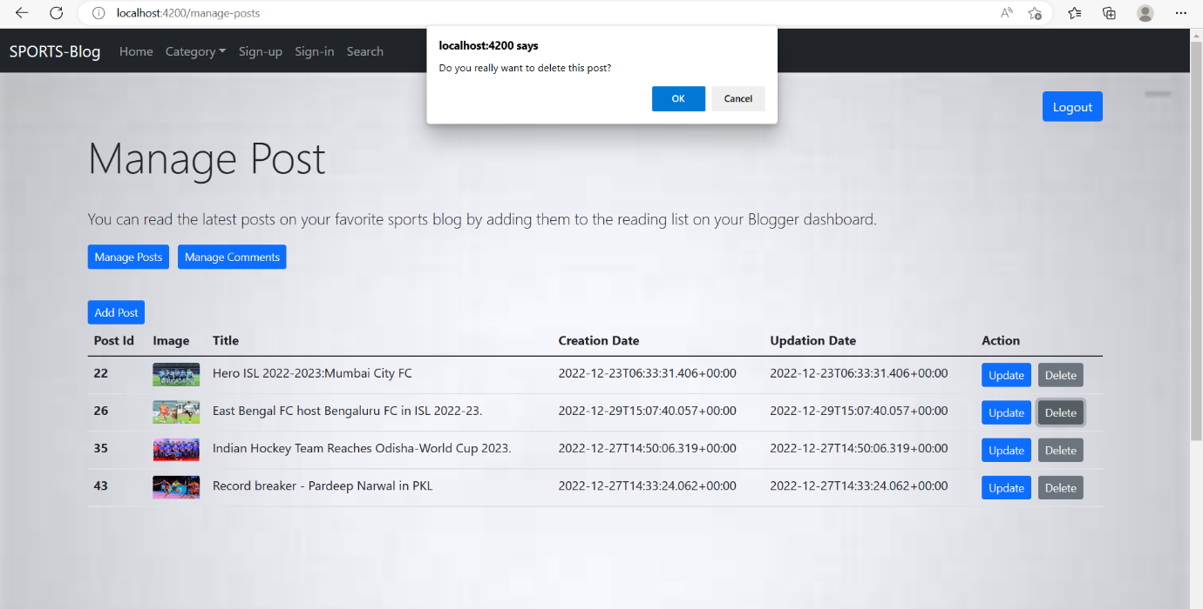

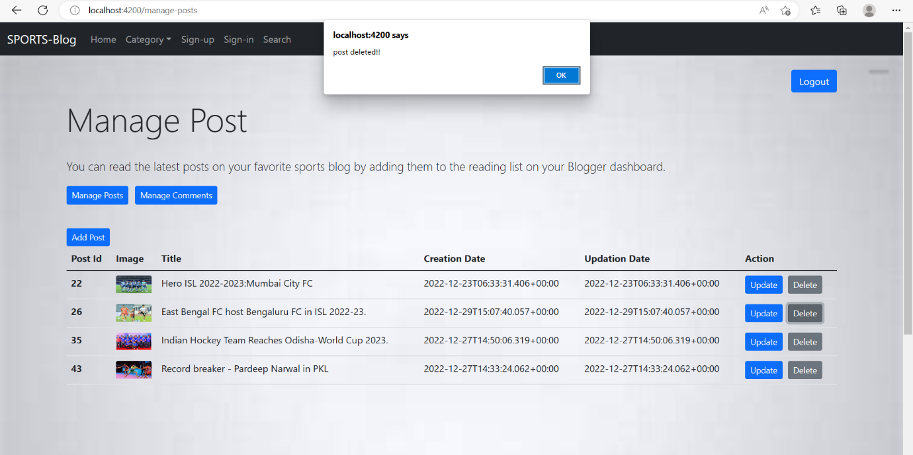

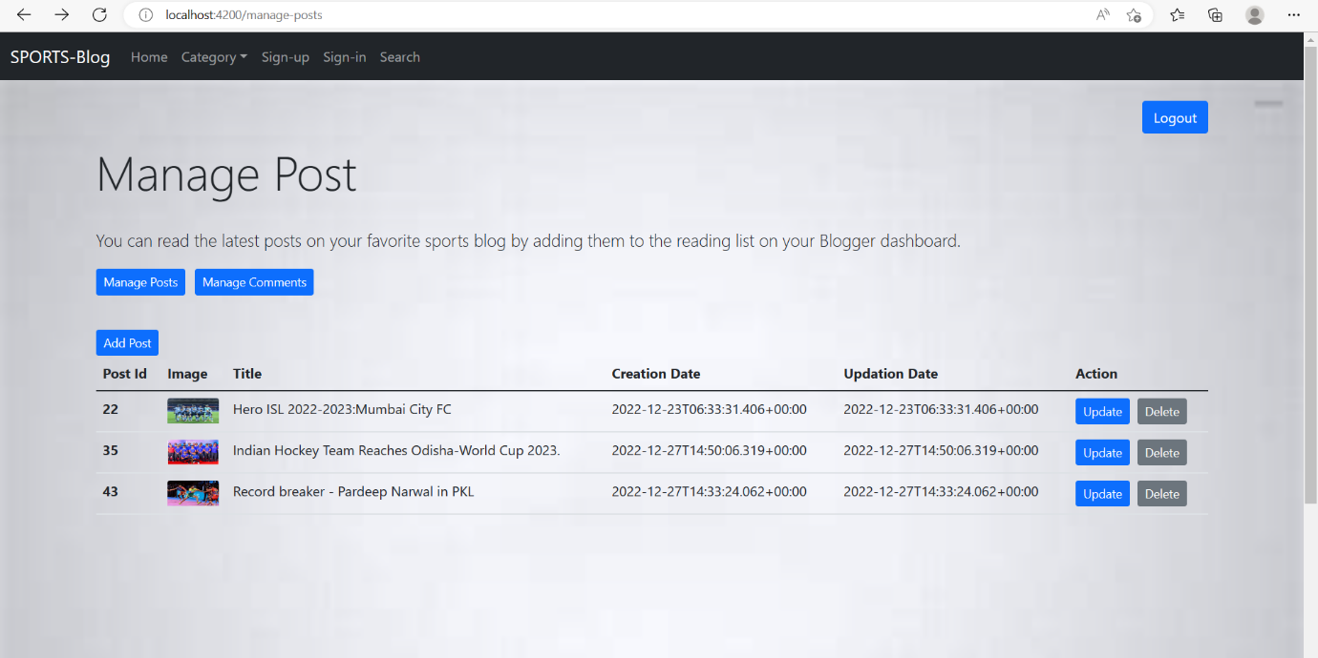

* User Update their own post :

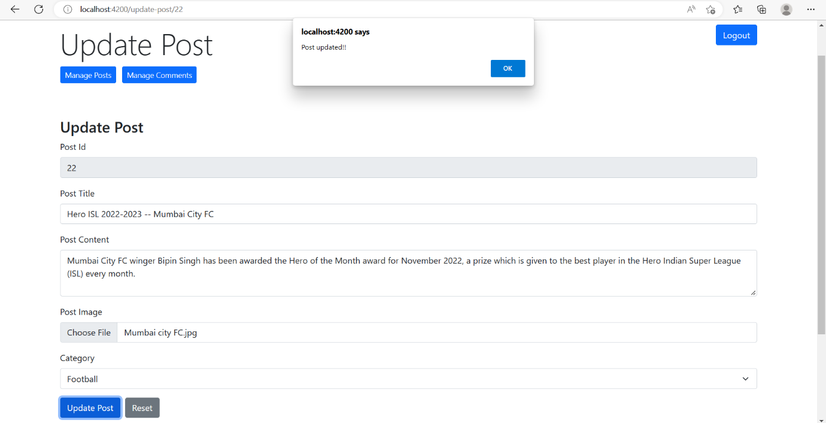

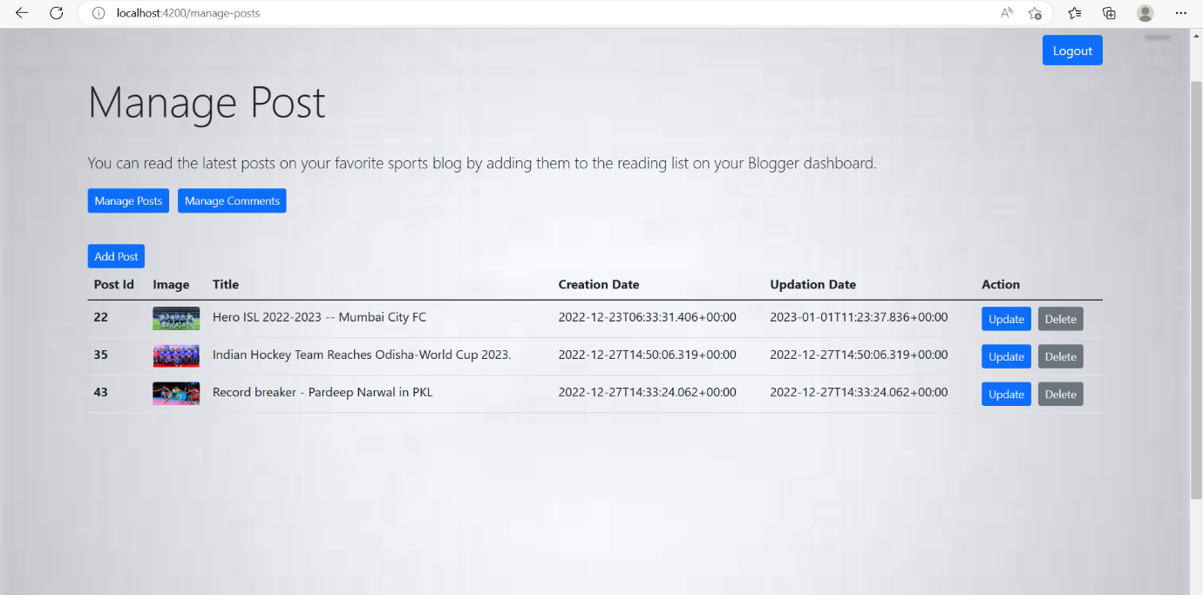

* User Update their own comments :

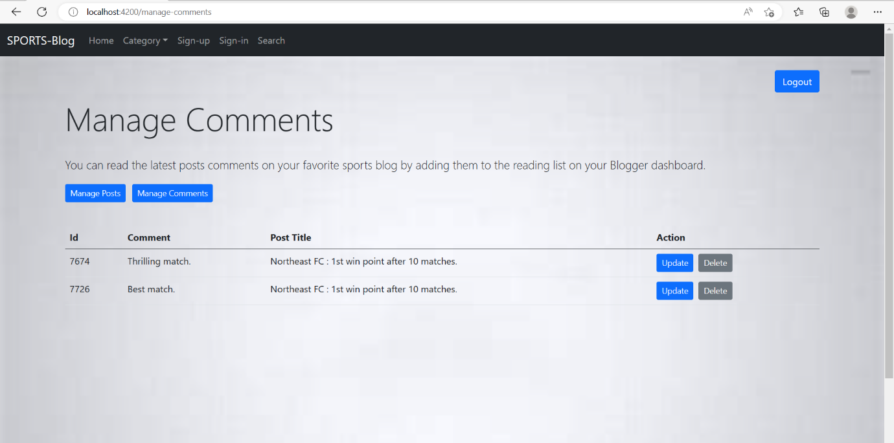

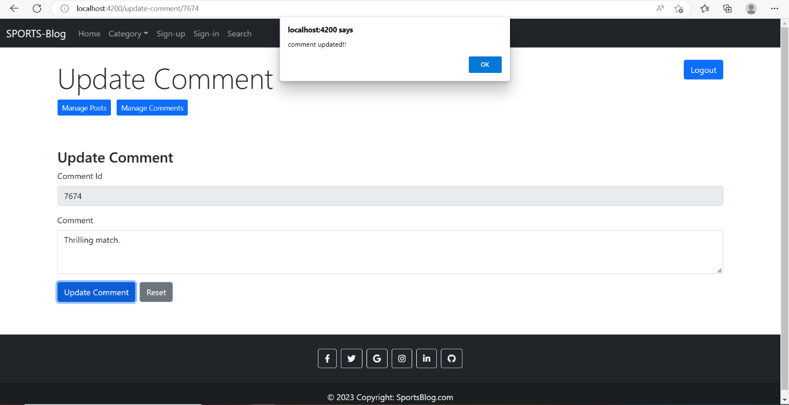

**Admin :**

* SignIn Page :

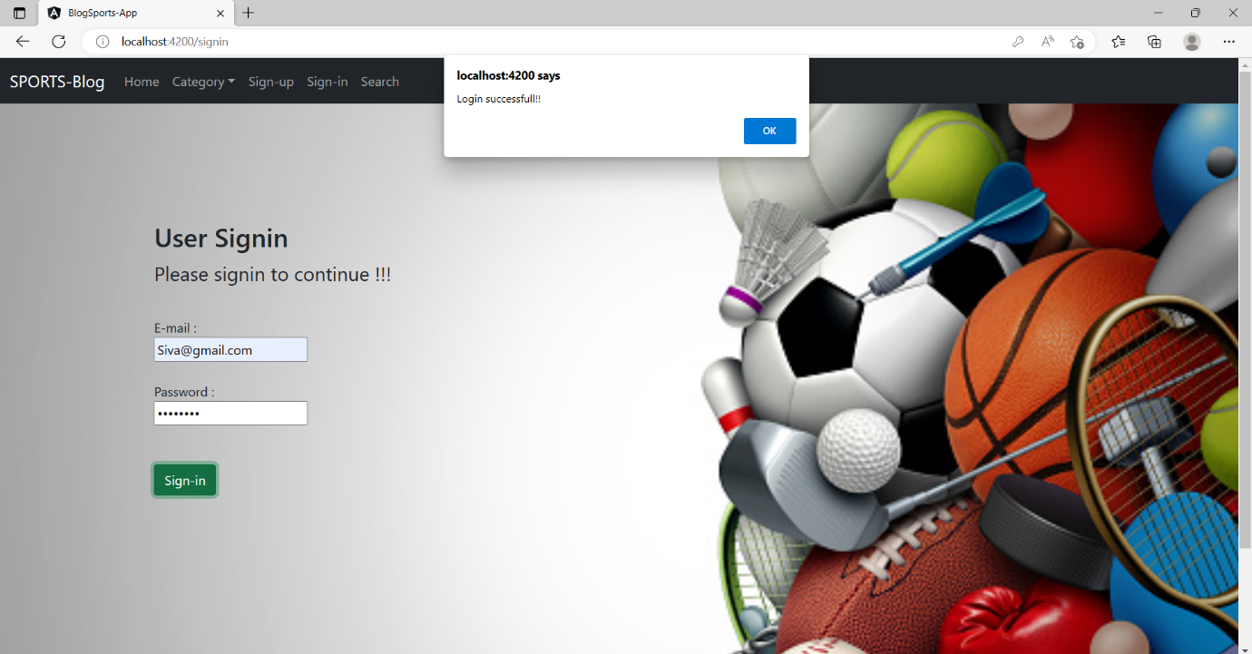

* Dashboard :

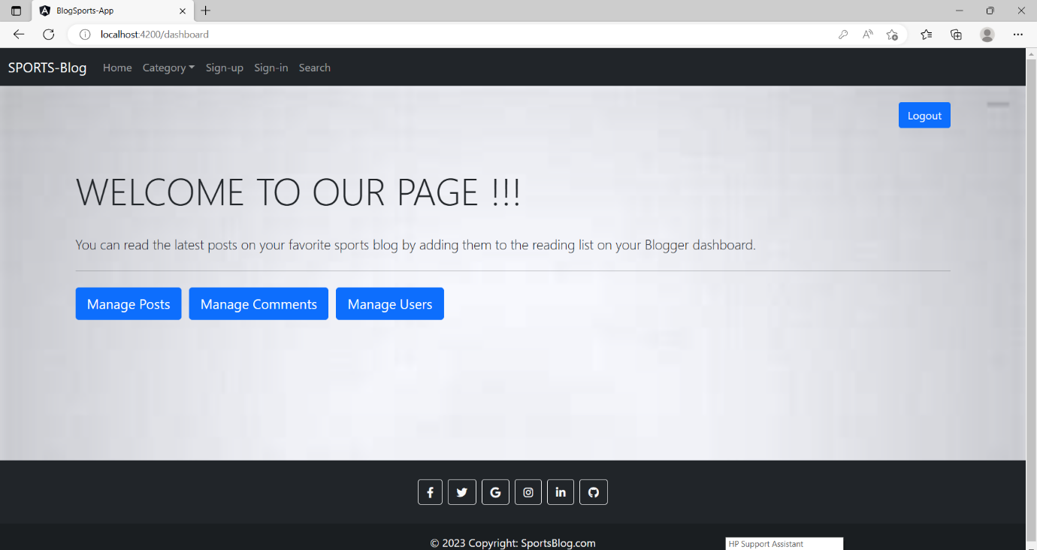

* Manage Post :

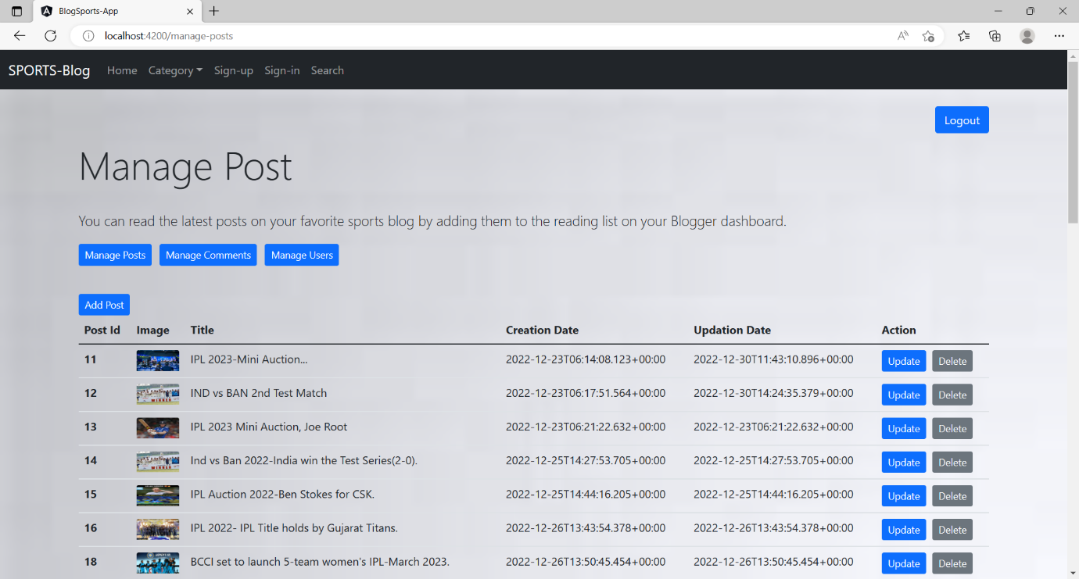

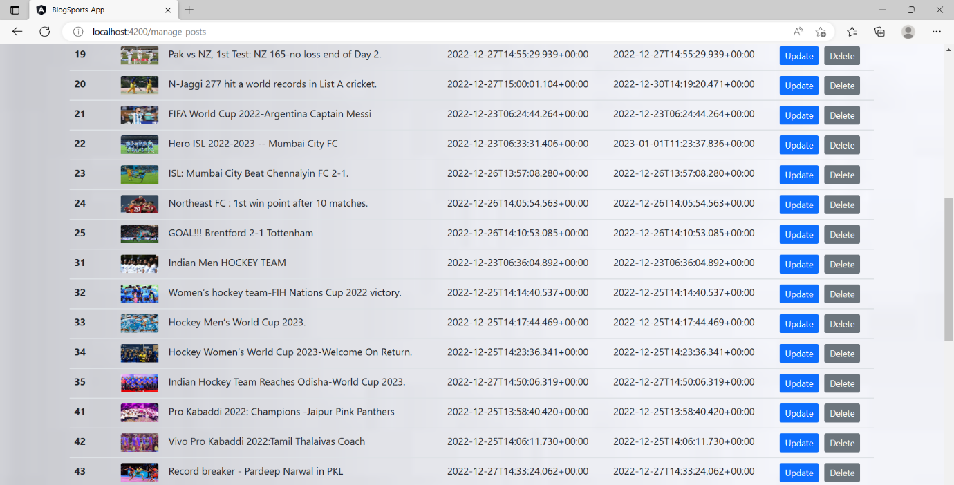

* Manage Comment :

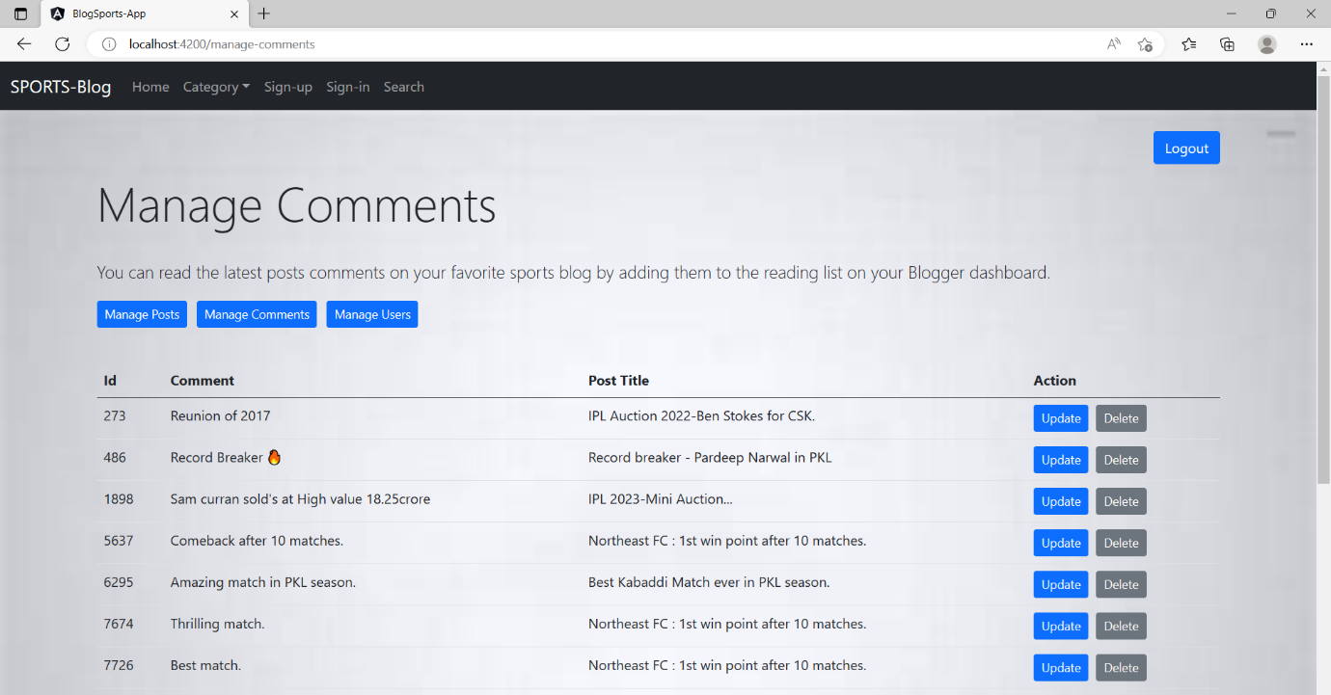

* Manage Users :

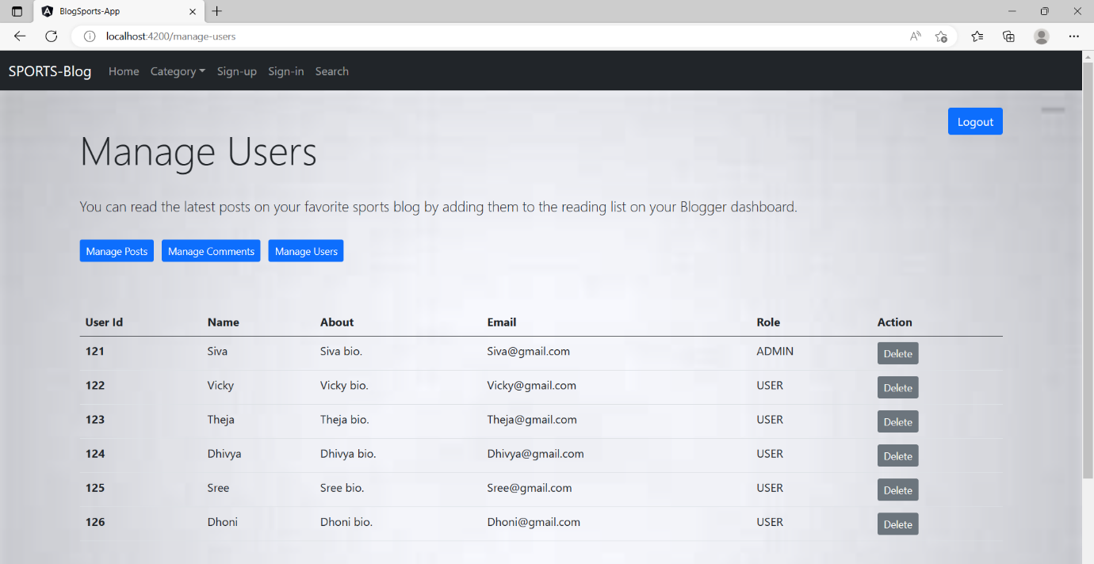

THANK YOU !!!